TEL: 781 768 -7270
FAX: 781 768 -7225
E-MAIL: finaid@regiscollege.edu
Center for Student Services
2018-2019 Identity & Statement
Of Educational Purpose

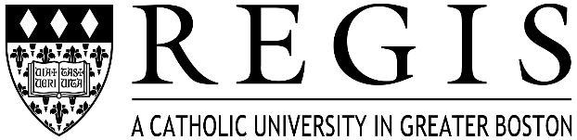

Student Name:___________________________________ Student SSN/Regis ID:__________

Certification of Identity

Your Free Application for Federal Student Aid (FAFSA) was recently reviewed. In order to comply with federal financial aid regulations, the student must appear in person at Regis College to verify his or her identity by presenting a valid government-issued photo identification (ID), such as, but not limited to, a driver’s license, other state-issued ID, or passport. The institution will maintain a copy of the student’s photo ID that is annotated by the institution with the date it was received and reviewed and the name of the official at the institution authorized to collect the student’s ID.

In addition, the student must sign, in the presence of a Regis College Financial Aid Services official, the following statement:

Statement of Educational Purpose

I certify that I (print student’s name) am the individual signing this Statement of Educational Purpose and that the federal student financial assistance I may receive will only be used for educational purposes and to pay the cost of attending Regis College for the 2018 – 2019 academic year.

Student’s Signature _______________________ Regis ID#________________ Date_________

Present this form with original valid government issued photo ID.
TO BE COMPLETED BY FINANCIAL AID ADMINISTRATOR
ID Type:
ID Number: | Exp:
FAA Name:
FAA Title:
FAA Signature: | Date:

